Project Executable Files

Date | 5 July 2026
Team ID | SWUID2026213859
Project Name | Rising Waters
Maximum Marks | 3 Marks

Project Executable Files
This section requires submission of all executable and deployable files for your project. Ensure all files are properly organized, named, and uploaded to the specified submission platform. The evaluator must be able to run or deploy your solution using the provided files and instructions.

Step 1: Submission Checklist

S.No | Item to Submit |  | Submitted  No / NA) | (Yes | /
1 | Complete source code (all files and folders) |  | Yes
2 | README / Setup Guide (instructions to run the project) |  | Yes
3 | requirements.txt / package.json / dependency file |  | Yes
4 | Database schema / seed files (if applicable) |  | NA
5 | Environment configuration file (.env.example similar) | or | No
6 | Deployed application URL (if hosted) |  | No
7 | APK / Executable binary (if applicable for mobile/desktop apps) |  | NA
8 | Dockerfile / Containerization config (if applicable) |  | No
9 | Test files and test results |  | Yes
10 | Demo video or walkthrough (if required) |  | Yes

Step 2: File / Folder Structure
Provide an overview of your project's file and folder structure below:

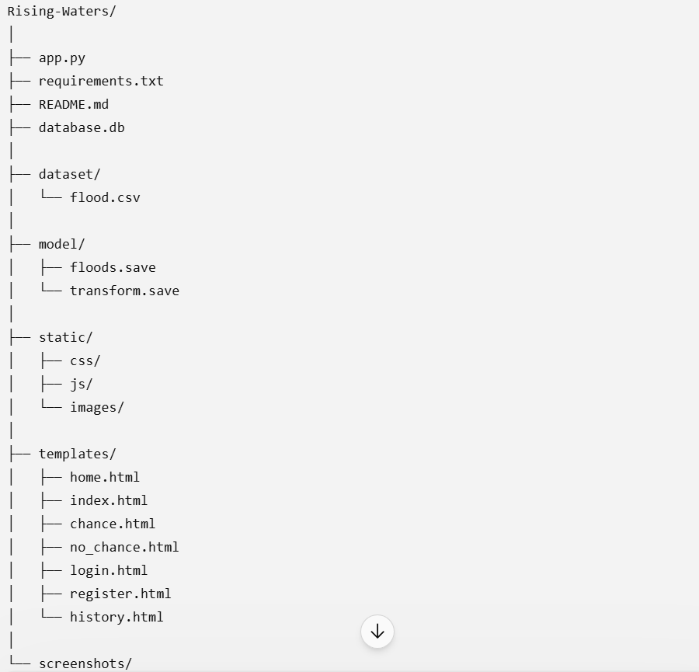

Step 3: Deployment / Access Details

Field | Details
Hosted / Deployed URL | Not Deployed
Login Credentials  (Demo) | NA
Platform / Hosting  Provider | [e.g., Render, Vercel, AWS, Heroku, Azure]
Repository Link | https://github.com/Navyareddy2005/Rising-Waters
Demo Video Link | https://drive.google.com/file/d/16LFzBZ6L4GtsuNRpi_7b7_CavmfT7fSZ/view?usp=drivesdk

Step 4: Run Instructions
Provide clear, step-by-step instructions for the evaluator to run your project locally:

- Clone the GitHub repository.
- Open the project in Visual Studio Code.
- Create and activate a Python virtual environment (optional).
- Install all required dependencies using:
- pip install -r requirements.txt
- Run the Flask application:
- python app.py
- Open the browser and visit:
- http://127.0.0.1:5000
- Enter the required flood-related parameters and click Predict to view the result.

Step 5: Known Issues / Limitations

S.No | Known Issue / Limitation | Workaround / Status
1 | Uses historical dataset instead of live weather data | Can be improved by integrating a real-time weather API.
2 | Cloud deployment not completed | Currently runs successfully on a local Flask server.
3 | No SMS/Email notification feature | Planned as a future enhancement.

